**Year 12 Physics TEST # 1 – Gravity & Motion I 2022**

NAME:

*Total Marks: 36 Time Allowed: 45 minutes*

(Formula sheet and scientific calculator permitted)

***Ignore frictional effects in all questions in this test.***

**Question 1 (3 marks)**

The diagram shows the trajectory of a soccer ball kicked from ground level from left to right. Point *X* is the highest point of the trajectory. The ball spends 1.20 s in the air.

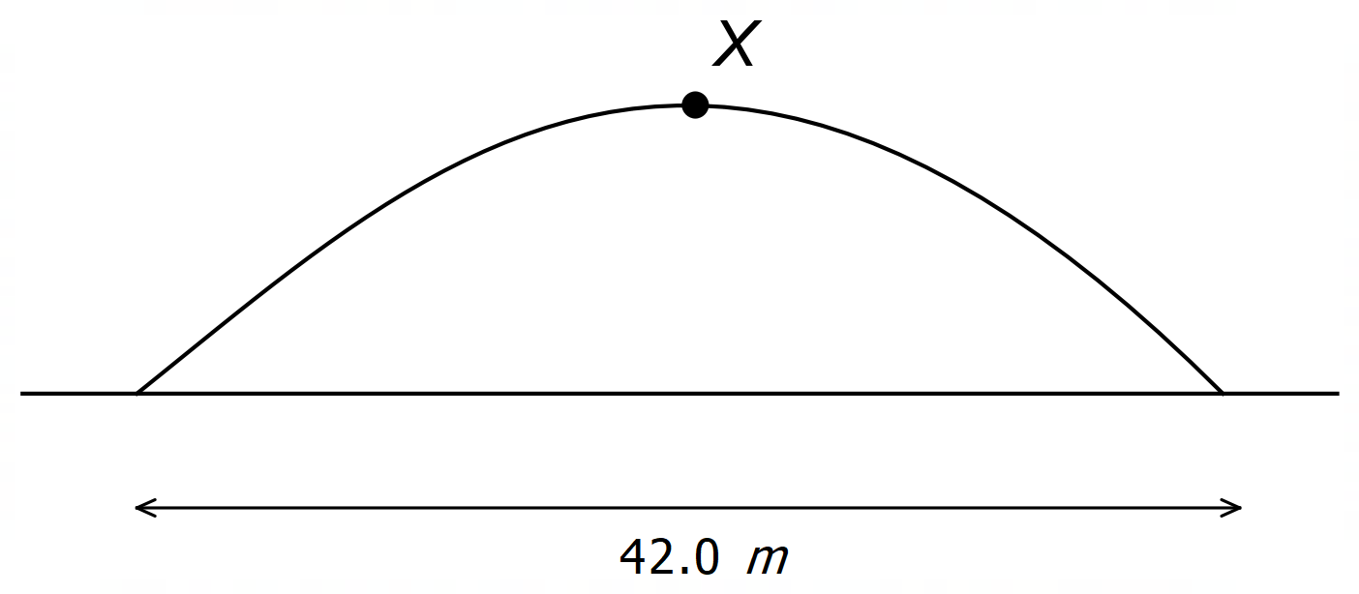

Draw labelled vectors on the diagram at point *X* showing the direction of the ball’s velocity and acceleration at that point, and write the magnitude on each vector.

**Question 2 (8 marks)**

At one point in its trajectory, a cricket ball of mass 0.160 kg, originally hit from ground level, has a horizontal speed of 8.70 ms-1 and a vertical speed of 5.40 ms-1.

1. What is the ball’s total kinetic energy at this point? [3]
2. How much higher will the ball rise from this point? [3]
3. What is the ball’s kinetic energy at its highest point? [2]

*See next page for Question 3*

**Question 3 (13 marks)**

Angus holds a small sphere of mass 120.0 g on a smooth plane inclined at 37.0° to the horizontal by applying a horizontal force, as shown below:

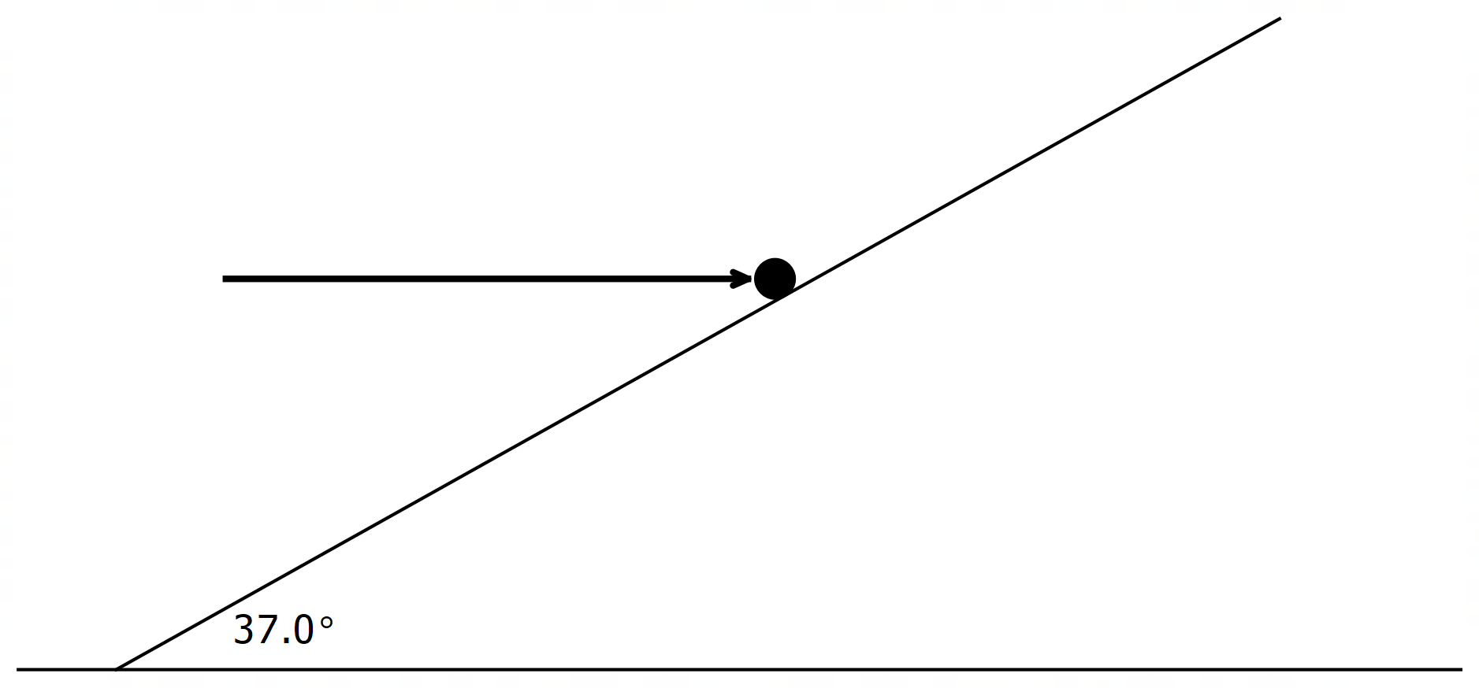

Angus’s force

1. Show and label, on the diagram above, all forces acting on the sphere and draw the components of these forces parallel and perpendicular to the plane. [4]
2. Determine the magnitude of Angus’s force. [4]
3. What is the magnitude of the normal reaction force of the plane on the sphere? [3]
4. Angus could apply a smaller force to hold the sphere in place if he pushed in which direction? Justify your answer. [2]

**Question 4 (12 marks)**

A child on an escalator moving downwards at 1.50 ms-1 throws a ball at 4.80 ms-1 (relative to the escalator) at right angles to the motion of the escalator, as shown in the diagram below.

Calculate the distance *d* indicated in the diagram.

(Hint: First find the angle *θ* and then the horizontal and vertical components of the 1.50 ms-1 velocity and the 4.80 ms-1 velocity.)

*(more working space on next page)*

*(Working space for Question 4)*

*- End of Questions -*